# **VISVESVARAYA TECNOLOGICAL UNIVERSITY**

Jnana Sangama, Belagavi-590018, Karnataka, India

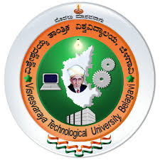

**A DBMS Mini-Project Report**

**on**

**“Food Ordering System”**

*A Mini-project report submitted in partial fulfilment of the requirements for the award of the degree of Bachelor of Engineering in* ***Computer Science and Engineering*** *of Visvesvaraya Technological University, Belgaum.*

**Submitted by**

**B S SAPNA KUMAR (1DT17CS113)**

**UNDER THE GUIDENCE:**

**MISS. K. DEEPA SHREE**

**(Asst. Prof. Dept of CSE)**

**and**

**Mr. SHIVA SUMANTH REDDY**

**(Asst. Prof. Dept of CSE)**

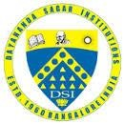

Department of Computer Science and Engineering

**DAYANADA SAGAR ACADEMY OF TECHNOLOGY AND MANAGAEMENT**

Kanakapura Road, Udayapura, Bangalore-560 082

2021-2022

**DAYANADA SAGAR ACADEMY OF TECHNOLOGY AND**

**MANAGEMENT**

Kanakapura Road, Udayapura, Bangalore -560 082

**DEPARTMENT OF COMPUTER SCIENCE AND ENGINEERING**



**CERTIFICATE**

This is to certify that the Mini-Project on Database Management System (DBMS) entitled **“FOOD ORDERING SYSTEM”** has been successfully carried out by **B S SAPNA KUMARI (1DT17CS113)** abonafide students of **Dayananda Sagar Academy of Technology and Management** in partial fulfilment of the requirements for the award of degree in **Bachelor of Engineering** **in Computer Science and Engineering** of **Visvesvaraya Technological University, Belgaum** during academic year 2021 - 2022. It is certified that all corrections/suggestions indicated for Internal Assessment have been incorporated in the report deposited in the departmental library. The mini project report has been approved as it satisfies the academic requirements in respect of project work for the said degree.

**Miss. K. DEEPA SHREE**

**(Asst. Prof. Dept of CSE) ______________________________**

**and**

**Mr. SHIVA SUMANTH REDDY**

**(Asst. Prof. Dept of CSE) ______________________________**

**EXTERNAL VIVA**

**Name of Examiners Signature with Date**

**1.**

**2.**